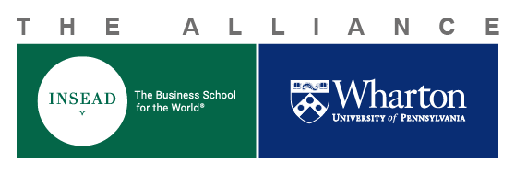
Alliance Center for
Global Research and Education Faculty Exchange
Funding Request
Application Process for INSEAD Faculty
- Once you have been approved for a Faculty Exchange (a Faculty Exchange Request Form has been signed by all parties and sent back to you), you are allowed to request funding.
- Complete all information below and submit this entire document (as a Word document / NO PDF) to the Alliance Research Director and the INSEAD and Wharton Administration teams for review of your budget request:
- Phanish Puranam, Research Director, phanish.puranam@insead.edu
- Rose Weiss, Wharton Administration, alliance.team@wharton.upenn.edu
- Pascale Gadroy/Alice Bandeira, INSEAD Administration, insead-wharton.alliance@insead.edu
- If approved, you will receive an email from your home school Alliance Administration with a budget number (Award Letter) along with all necessary information regarding the use of the allocated funds and the reimbursement process.
- Exchange budgets up to €15,000 require approval from the Alliance Research Director. Any budget exceeding €15,000 cannot be approved.
- Eligible expenses may be claimed and reimbursed on an ongoing basis throughout the exchange period, provided that the allocated budget is not exceeded.
All reimbursement requests must be submitted by the end of the calendar year in which the travel took place.

Application Details
Your First name, Last name | Click or tap here to enter text.
Your INSEAD/Wharton Email Address | Click or tap here to enter text.
Date of your request (YYYY-MM-DD) | Click or tap to enter a date.
Exchange Scheduled Visit Dates (YYYY-MM-DD) | From: Click or tap to enter a date.  To: Click or tap to enter a date.
Your Department / Area Name | Click or tap here to enter text.
Your Home School (Wharton or INSEAD, specify your campus (Asia, Europe, Middle East, INA) | Click or tap here to enter text.
Name of the faculty member inviting you at the host institution: | Click or tap here to enter text.
Department / Area of the faculty member inviting you at the host institution | Click or tap here to enter text.
Email address of the inviting faculty member at the host institution: | Click or tap here to enter text.

Budget Request & Reimbursement Process

Double-click on the following Excel table to enter your budget request. The formula will calculate your total budget and the conversion from USD to Euros as necessary. Reimbursements will be made only upon submission of original receipts.

- All budgets will be awarded in EUR and will be adjusted to reflect the exchange rate on the date of the expense
- Reimbursements will be processed as soon as possible following your return and only upon submission of original receipts to your home institution, as follows:
- INSEAD faculty = expense claim is processed by your Faculty Support Coordinator (FSC)
- Wharton faculty = expense claim is processed by your Business Administrator (BA)
  - Please provide a copy of the approved funding application form, including the budget number and approved funding amount, when submitting your expense claim
- Eligible expenses may be claimed and reimbursed on an ongoing basis throughout the exchange period, provided that the allocated budget is not exceeded.
- All reimbursement requests must be submitted by the end of the calendar year in which the travel took place.
- Per diem is not allowed; meals are not reimbursed.
To be completed by the Alliance Administration

Date of Approval: Click or tap to enter a date.
Amount Approved in Euros: Click or tap here to enter text.
INSEAD-Wharton Project #: Click or tap here to enter text.

