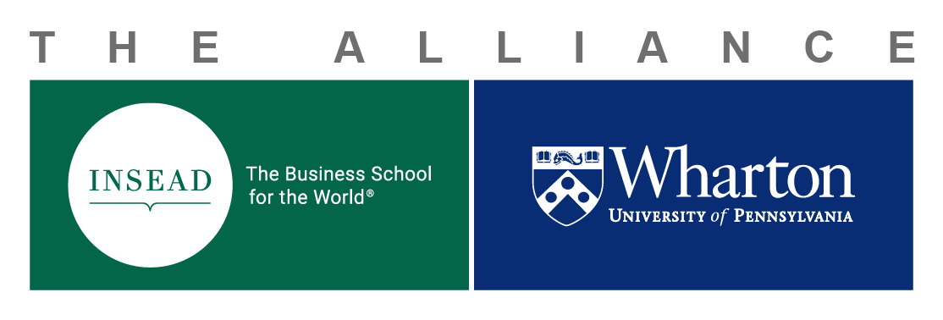
INSEAD-Wharton Center
for Global Research and Education
PhD Student Exchange
Funding Request
Funding Application Process
You need to have an Alliance Doctoral Student Exchange Request form duly signed and approved before filling out the funding request below:
- Exchange funding requests should be completed and sent by email to the Alliance Research Director and the Alliance Administration as follows:
  - Phanish Puranam: phanish.puranam@insead.edu
  - Rose Weiss, alliance.team@wharton.upenn.edu
  - Pascale Gadroy/Alice Bandeira: insead-wharton.alliance@insead.edu
- Financial support (travel and housing) – Once a student receives a letter of invitation from the PhD program office of either school, they may apply for financial support by submitting this funding request. Support may be granted following the successful completion and approval of the application and budget, acceptance of the terms and conditions, and submission of a copy of the student visa to the INSEAD-Wharton Alliance team (see emails above).
Note: All approvals must be obtained at least two (2) months before departing for the host institution.
- Items covered: travel (one return economy class airfare), ground transportation (taxi to and from airport for departure and return trip), and residence/housing/apartment (Fontainebleau or Philadelphia housing up to €1000 per month, and Singapore is up to €1475 per month).
- Items not covered: books, utilities, or technology-related purchases (computers, cell phones, etc.), living expenses such as meals, local transportation, and telephone charges covered by your stipend.
- Acceptance to the PhD Exchange Program is not a guarantee of receiving funding from the Alliance.
- All budgets are awarded in Euros and will be strictly adhered to.
- Reimbursements are processed at your home school after submission of original itemized receipts. Please read the process for each partner school:
- Wharton Reimbursements: Contact your Departmental Business Administrator
- INSEAD Reimbursements: Complete the “Reimbursement Request for External Beneficiary” and send it with all original scanned receipts to your home campus Accounts Payable (accounts.payablefr or sg@insead.edu).
- All reimbursements must have an approved project number (2399-xxx) from the Alliance and must be submitted with the initial Budget Request (this form).
- Eligible expenses may be claimed and reimbursed on an ongoing basis throughout the exchange period, provided that the allocated budget is not exceeded.
- All reimbursement requests must be submitted by the end of the calendar year in which the travel took place.
- Meals are not reimbursed.
Funding Application
Please double-click on the following embedded Excel worksheet and update as appropriate. The formula will calculate your total budget and convert from USD to EUR as soon as you complete the Exchange Rate in the yellow cell below:
To be completed by the Alliance Administration
Date of Approval: Click or tap to enter a date.
Amount Approved EUR: Click or tap here to enter text.
INSEAD-Wharton Alliance Project #: Click or tap here to enter text.

