Student Sponsorship Agreement

This Agreement is made on [Date] _________________

Between:
- INSEAD, located at 1 Ayer Rajah Avenue, Singapore 138676, (“INSEAD”);
and
- Sponsor Company name: ____________________________
(the “Sponsor”)

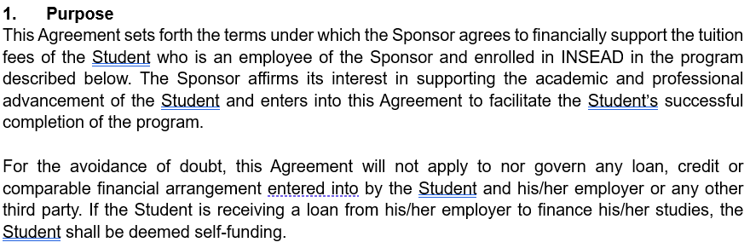

Student Information

Student name: ___________________________________________
Program: INSEAD MBA Programme, class of July 2027
Starting / Home campus: Singapore

Sponsorship Coverage
The Sponsor agrees to pay the tuition fees for the Student as invoiced by INSEAD subject to the terms of this Agreement and all other agreements, codes and policies applicable to the Student. The fees for the August 2026 MBA intake are €109,860.

- The Sponsor agrees to pay for the said fees fully.
- The Sponsor agrees to pay the amount of ______________.

The Sponsor agrees to make payment to INSEAD as follows:
 | Amount | Due date
First instalment | €12,000 | Approximately 4 weeks after having received the admissions offer
Second instalment | €97,860 | 20 May 2026 (for application round 1 and 2) 15 July 2026 (for application round 3 and 4)
Any installments or amounts personally paid by the Student in respect of the tuition fees covered under the agreed sponsorship shall be reimbursed by the Sponsor to the Student directly. The Student shall remain solely responsible for seeking and obtaining such reimbursement and INSEAD shall have no involvement, obligation or liability in that regard.

Sponsor payment information
INSEAD will issue the invoice for the sponsored amount to the Sponsor based on the information provided below. In the event of any changes in the information below, the Sponsor is required to inform INSEAD in writing before the commencement of the programme i.e. by 21st August 2026. INSEAD cannot make any modifications to the invoice after the start of the programme.
Sponsor address for the invoice:
Tax ID:
Trade License number:
PO number (if applicable):

Name of the person who will be making the payment:

Email address:
The accurate name and the e-mail for the above are important as this person will receive a personalized link to pay through Transfermate that INSEAD has partnered with to receive tuition fee payments.

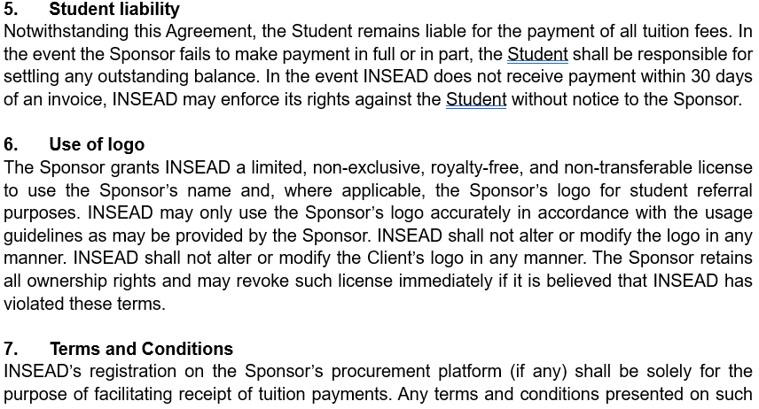

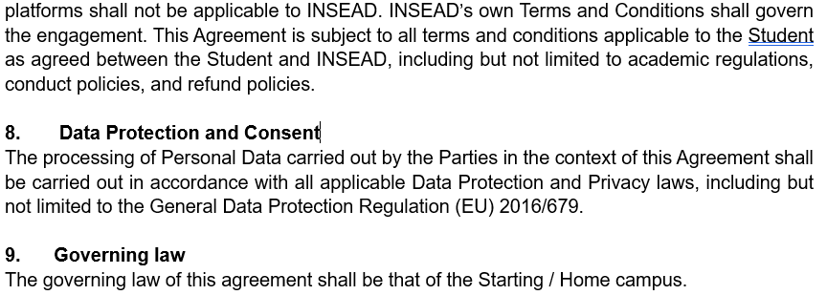

Signed for and on behalf of Sponsor
Name of Sponsor representative:
Signature:
Company stamp:
Date:

Signed for and on behalf of INSEAD
Name of INSEAD representative: Nancy Gabriel, Executive Director for Admissions,
Scholarship & Financial Aid
Signature:
Date:

