INSEAD-Wharton Center
for Global Research and Education
Ph.D. Student
Short Term Visit Request
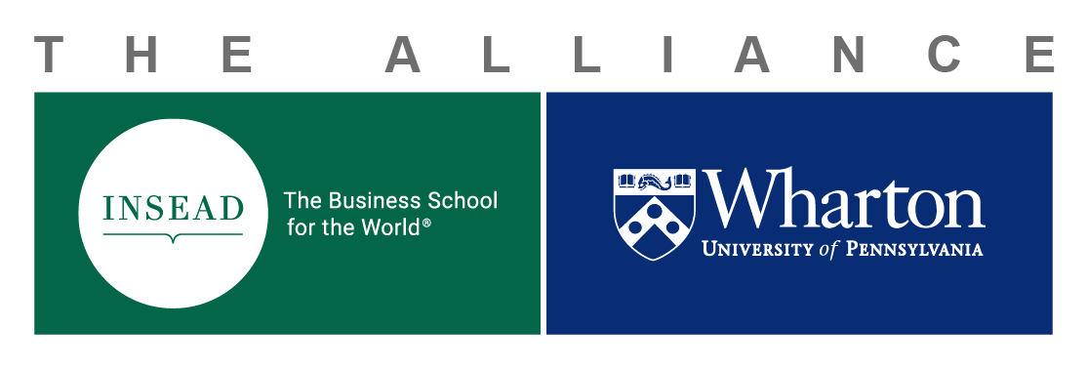

Definition of a Ph.D. Student STV

Designed in part to allow Ph.D. students to visit the partner school to conduct research under the guidance of a faculty sponsor at the partner school. The duration of a Short Term Visit (STV) for Ph.D. research can be up to four (4) weeks.
STVs can also be used to attend co-branded (INSEAD and Wharton) conferences or workshops. Attendance for these events can be up to three (3) nights and must be relevant to the student’s research. Ph.D. STVs cannot be used for the annual Ph.D. Student Consortium, which is funded separately by the Alliance.
The Alliance will grant a total of two (2) STVs per academic year, per school. Students are permitted to participate in one approved STV during their Ph.D. studies. First year students are not eligible.

4-Week Visit: Applications for STVs of maximum 4-week duration must be submitted by 31 May of the calendar year.
Colloquia: A Short-Term Visit request relating to colloquia will require the application be submitted at least two (2) months prior to departure date.

Financing for Ph.D. student exchanges are only open to Ph.D. students and at least in the second-year of the Ph.D. program.

Application Process

- Student must first receive an (email) invitation from a faculty sponsor from the partner school, to conduct research under their guidance, or to attend a co-branded conference or workshop relevant to the student’s research;
- student must then get approval from their Ph.D. Advisor and Ph.D. Department Coordinator;

- once the aforementioned steps are fulfilled, student will complete the application below and forward it the following persons accompanied by their invitation:
Guillaume Roels, Research Director, INSEAD-Wharton Alliance, guillaume.roels@insead.edu
Michele Anna Klekotka, Administrative Manager, INSEAD-Wharton Alliance, klekotka@wharton.upenn.edu
Suzanne Sellier Di Sano, Manager, INSEAD-Wharton Alliance, suzanne.sellierdisano@insead.edu

- Should the student’s application be approved, Michele Klekotka will send an award letter which will include the approved budget amount with corresponding budget number, to be used for reimbursements. Please note original receipts are required for reimbursement.
- Upon completion of the STV, student is required to submit a 500-word summary to the Alliance summarizing the results of their visit.
Application for Ph.D. Student STV
Name: Email Address:
Date of proposed visit (To/From): mm/dd/yyyy Student’s Department Name:
mm/dd/yyyy Faculty Sponsor from Partner School:
Student’s Home School (Wharton or INSEAD): Name of student’s Ph.D. Advisor
Nature of the STV:
Research under the guidance of Faculty Sponsor Professor (named above);
Conference or Workshop. Only co-branded events relevant to your research and held at INSEAD or Wharton will be covered (air travel, ground transportation to/from airports, accommodation up to 3 nights).
Title of Conference/Workshop:
Provide an explanation for why you are requesting an STV for your research:

If attending a co-branded conference or workshop, please provide the title of the event and how it is relevant to your Ph.D. studies:

Approval signature of Ph.D. Advisor: _____________________________________________
Approval signature of Ph.D. Department Coordinator: _____________________________________________
Faculty Sponsor signature: _____________________________________________
Approval signature Ph.D. Vice-Dean/Academic Director: _____________________________________________

Budget Request

All budgets will be awarded in Euros and will be adjusted to reflect the Exchange Rate at the date of the expense.
Reimbursements will be paid upon submission of original receipts only. Double-click on the Excel table below to enter your budget request. Formula will calculate the conversion from USD to Euros as necessary.
Short Term Visits:
- Funding up to four (4) weeks pending Alliance approvals
- One round trip economy airline ticket to host school with cap of 1,000 Euros for France and 1,600 Euros for Singapore.
- Ground transportation to/from airports (Philadelphia and INSEAD)
- Accommodation for up to (4) weeks and maximum 1000 Euros for Philadelphia and Fontainebleau (or 1,474 Euros for Singapore) including taxes per visit
- No Per Diem
- Original itemized receipts required
Visas must be handled by the student and proof of visa should be provided before departure.
Conferences or Workshops:
- Funding up to three (3) nights pending Alliance approvals for:
- Attendance at a co-branded (Wharton and INSEAD) conference/seminar at partner school for up to (3) nights
- Accommodations should be arranged by host department at partner school. Lodging covered up to (3) nights to a maximum of 200/Euros per night, including taxes
- One round trip economy airline ticket to host school with cap of 1,000 Euros for France and 1,600 Euros for Singapore.
- Ground travel to/from the airport
- No Per Diem
- Original itemized receipts required

To be completed by Michele Anna Klekotka, Alliance Manager
Date of Approval: Amount Approved €: Wharton-INSEAD Project #:

