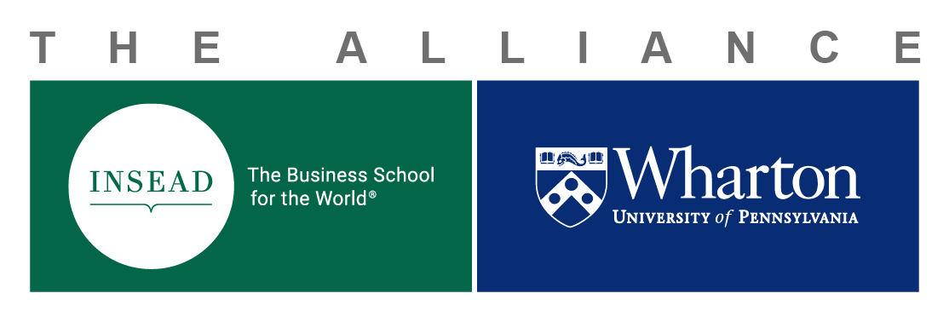
INSEAD-Wharton Center
for Global Research and Education
Ph.D. Student Exchange
Funding Request

Funding Application Process

- Requests for funding should be made to the Director of the Alliance Research Centre – Guillaume Roels: guillaume.roels@insead.edu and copy to Michele Klekotka: Klekotka@wharton.upenn.edu

- Financial support (travel and housing) – once a student receives a letter of invitation from the Ph.D. program office for either school, financial support may be available by submitting this funding request. Support may be awarded after successful completion and approval of both the application and budget, review and acceptance of terms and conditions, and a copy of student visa are sent to Michele Klekotka, Klekotka@wharton.upenn.edu
Note: All approvals must be obtained two (2) months before the registration date at the host institution.
- Items covered: travel (one return economy class airfare), ground transportation (taxi to and from airport for departure and return trip), and housing/apartment (INSEAD-Fontainebleau residence, Fontainebleau or Philadelphia housing up to €1000 per month, and Singapore is up to €1475 per month).
- Items not covered: books, utilities or technology related purchases (computers, cell phones, etc.), living expenses such as meals, local transportation and telephone charges covered by your stipend.
- Acceptance to the Ph.D. Exchange Program is not a guarantee of receiving funding from the Alliance Research Center.
- All budgets are awarded in Euros and will be strictly adhered to.

- Reimbursements are processed at the home school after submission of original itemized receipts. All original receipts will need to be reviewed and approved by the home school prior to payment by the designated staff person below:

- Wharton Reimbursements: Contact Departmental Business Administrator
- INSEAD Reimbursements: Contact Dorothée Simon, Department of Research Administration: dorothee.simon@insead.edu

- All reimbursements must have an approved project number (2399-xxx) from the Alliance, and submitted with the Request.
- Funding and reimbursements will cease at the end of the visit to the host school, and do not rollover.
Double-click in the following Excel table to enter your budget request. Formula will calculate your total budget, and the conversion from USD to Euros as necessary.

Funding Application

Please click twice on the embedded excel worksheet:

To be completed by Michele Klekotka, Administration Manager for the Alliance

Date of Approval: Amount Approved €: Wharton-INSEAD Project #:

